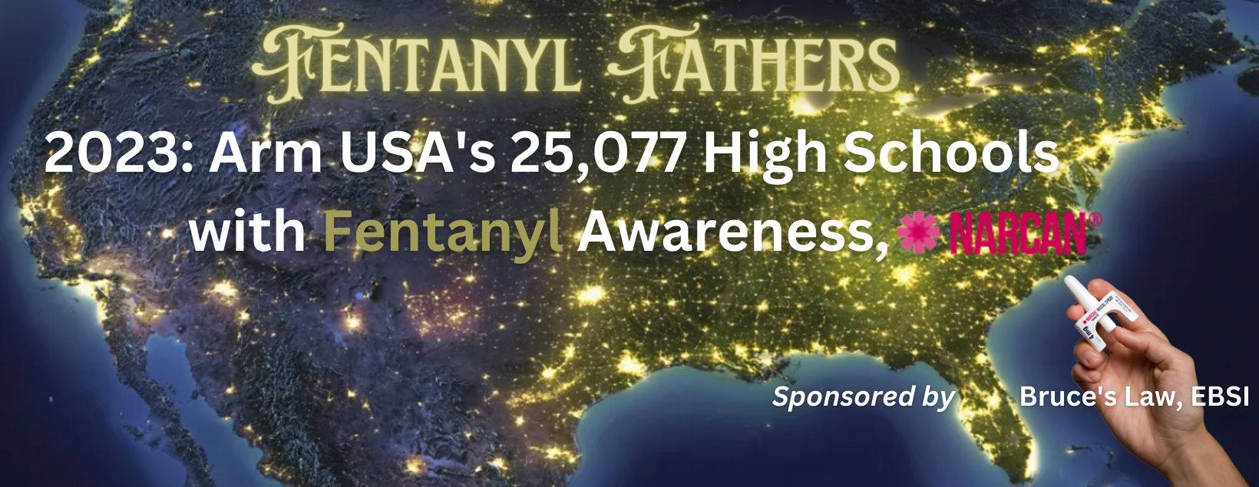

Summary: Fentanyl poisoning is the #1 reason 107,622 young Americans died in 2021 - or one full plane crash per day. High School Ages 14-18 are the target of fentanyl producers. The CDC has lowered the death range to start at age 14. Fentanyl Fathers will make all US High Schools aware and prepared - saving over 75,000 lives in 2023!

High school students need to be directly warned of the 60% likelihood of death. 6 in 10 pills contain lethal amounts of Fentanyl. To reach the 25,077 high schools with an effective Fentanyl awareness presentation, bereaved parents need to be recruited and assigned every USA school district with assemblies already booked. Acceptable deaths: Zero; Realistic 2023 goal: “Only” 25,000, or 1 per H.S. Catholic Schools are the starting point as they can be centrally mandated for Fentanyl awareness now.

1) The Need: 67% of U.S. High School Students are unaware of the fatal risks of fentanyl, where 6 in 10 pills have a lethal amount of fentanyl. This group needs to know as soon as possible. Media alone has failed. Live school assemblies are effective.

2) Discussion: Percocet, Adderall, Xanax, Oxycontin and other famous opioid brands are being forged to look authentic - but have been pressed with Fentanyl and sold on Snapchat and other social media apps.

3) Solution: Strategic organization in all 50 States to present a fact based, highly engaging and effective live presentation to High School students by a bereaved parents (FentanylFathers.org) providing assemblies awareness that their life is truly on the line.

4) Recommendation: Execute a 3 phase national roll out starting with Phase 1: East Coast, Midwest and West coast Catholic Schools. Sponsor: In consideration for Emergent getting an exclusive recommendation and NARCAN hand out at the end of each presentation to stock every home medicine cabinet (preparedness), EBSI will cover expenses of our rollout until “Bruce’s Law” awareness grants are available in July. A $97,500 Phase 1 budget = $2,000 for 47 schools and $3,500 for AK & DC travel expenses. A tax deductible donation goes to 501c3 National Defense Foundation for 100% purposes of Fentanyl Fathers. Phase 2 is regional executions. Phase 3 is national assemblies backed by location media ads using GODclick, Quorum, and Vistar.

Phase 1: Three pilot areas – East Coast, West Coast & Midwest – starting with Catholic High Schools: Michigan – 24, Anchorage & Fairbanks Alaska – 5, Washington DC – 18.
Success ~ Assembly: “I VOW to NEVER TRY so I will NEVER DIE from FENTANYL.”

