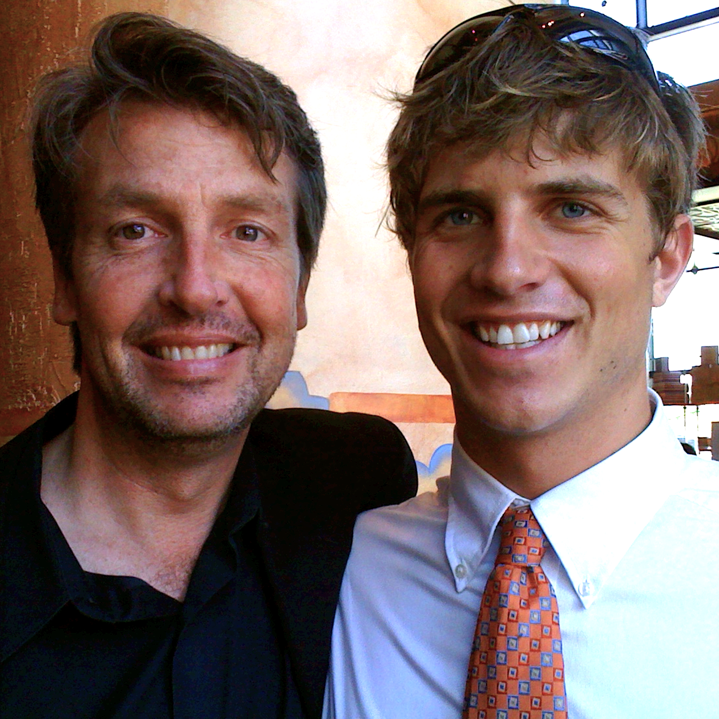
Drew Swan, 24. Opioid Epidemic Victim. Died April 3, 2013 Plantation Florida | DrewSwan.com

Childhood: My first born son Drew Swan was born April 10, 1988. Up until that point it was the happiest day of my life. My thought that day that “even if I die, I will live on through him.” I experienced the same thrill when his only brother Jack was born the following year. We were now the Swan Family of four now, and we made it up together -life- as we went along. We homeschooled our children in innocent Oconomowoc Wisconsin as I ran a small business. At age 11, Drew took a standardized test and placed “Collegiate level in 21 of 22 categories”. Drew was also an exceptional athlete. As a freshman in a 2000+ student Arrowhead High School, Drew was a key member of a state championship swim team and the MVP of his varsity tennis team. Drew achieved the Life Scout ranking as a Boy Scout, and balanced his approach by singing in the school choir. I shall never forget hearing their school version of The Christmas Shoes as we proudly watched him as a family. Drew painted as well - and he knew I liked Van Gogh. He replicated “Starry Night” to near perfection and presented to me. What a gift! Drew was voted “Best Looking” in his high school and was runner up for Student Body President. It was in High School that Drew sustained an athletic injury and was put on pain meds. Later he was given some unprescribed Oxycontin at a party - and he became hooked on opioids.

Drew’s College Years were spend at UWM and he graduated. Drew studied a year abroad in Australia and made wonderful friends from around the world and wrote music. His addiction eventually caught up with him as he could no longer afford it - and he called me for help. Drew interned for me at my digital sales office in Michigan - and helped me start GODclick.com, accurately predicting - in 2010 - that “Programmatic was the future of digital advertising.” Later I ended up doing an intervention on Drew in Milwaukee, and a week later, after a strong encouragement from his brother Jack, he entered treatment at Rosecrance in Illinois. Upon successful completion, Drew moved to halfway house in Florida and supported himself with retail and waiter jobs. I helped him get his own apartment.

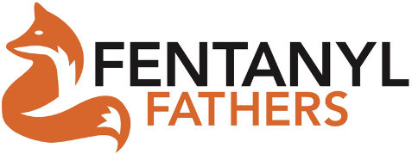
Final Years: Drew created a blog site and became a beautiful writer. He was planning entrepreneurial adventures, had started “The Progressive Group” and his future looked extremely bright. I spent a wonderful long weekend with him in February, 2013, at Disney World. In March we grabbed “DrewSwan.com" for his writing, and I sent him a calendar of photos we took of him at Epcot with “Women Around The World” along with his own business cards. Drew was volunteering for homeless people to get their clothes dry cleaned for interviews. He was proud of himself, and so was I. Unfortunately in March he attended a rave in Miami and relapsed on a “Molly”. My last conversation with him was March 31. He spoke to his brother April 1, and his mother April 2, saying he “had to get back on track”. He died of an unprescribed pill we believe the got from his roommate in his government assisted housing on April 3rd. The Swan Family party was over. We were absolutely gutted with the loss of Drew. My wife and I brought awareness to the epidemic running for congress in 2018 getting a mention in the SOTU address that year. The $6B budget that resulted was spent on PSAs, but the death decline was negligible. Jack became a doctor of emergency medicine hoping to save other “Drews.” It has taken 10 years to come to terms with the loss but we finally settled on a go forward solution of coping: warning kids directly - in person - about how fentanyl kills. Drew's brother Jack and I started "FentanylFathers.org" with the goal of presenting Fentanyl Education Awareness to all USA High School Assemblies by drawing from the workforce of 600,000 bereaved parents created over the last three years. We’re both a life saving prevention for unaware students and would be bereaved parents, and we’re a ministry with redeeming purpose for those who have lost her kids. We are set on becoming Fentanyl’s Madd.org.

